Carolyn Kennett

Dr. Zhou

GEOG 40323

4 November

Lab 6: Remote Sensing and NDVI Analysis

**Premise**   
This lab focused on using **remote sensing** and **raster analysis** in ArcGIS Pro to measure vegetation change in the **Columbus, Ohio** area over time. Using **Landsat imagery from 2002 and 2011**, I calculated the **Normalized Difference Vegetation Index (NDVI)** for each year and generated a **difference raster** to visualize areas where vegetation increased or decreased.

I personally created all NDVI maps and difference rasters from raw satellite imagery rather than using provided outputs. Through this process, I learned how NDVI values reflect vegetation health and how raster math can quantify landscape change. The final maps highlighted patterns of vegetation loss related to urban expansion and agricultural shifts, along with regions of regrowth or stable vegetation cover.

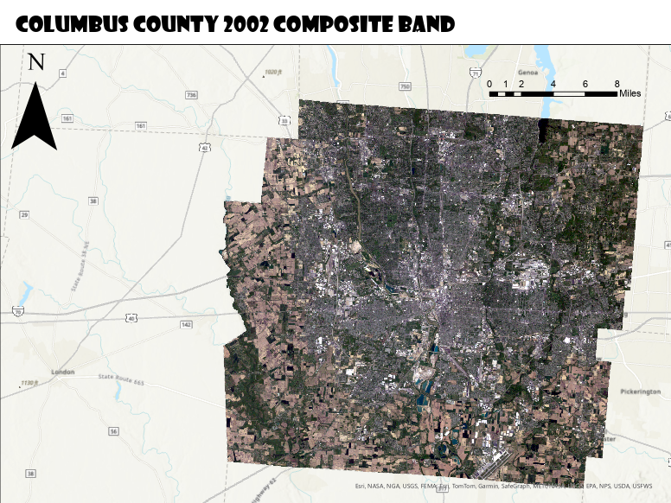

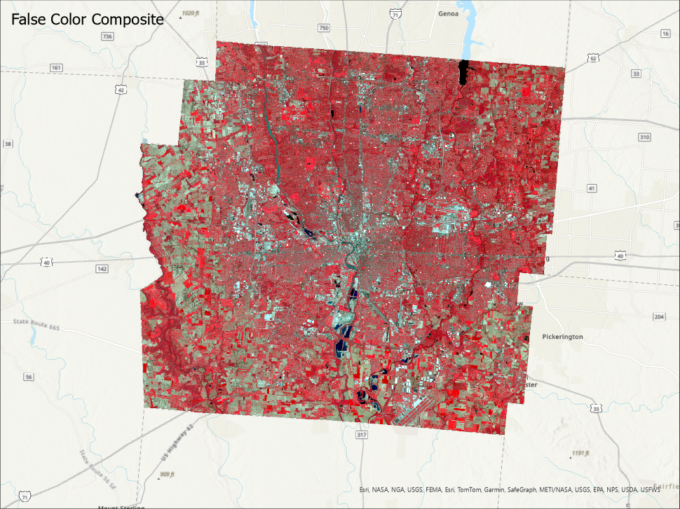

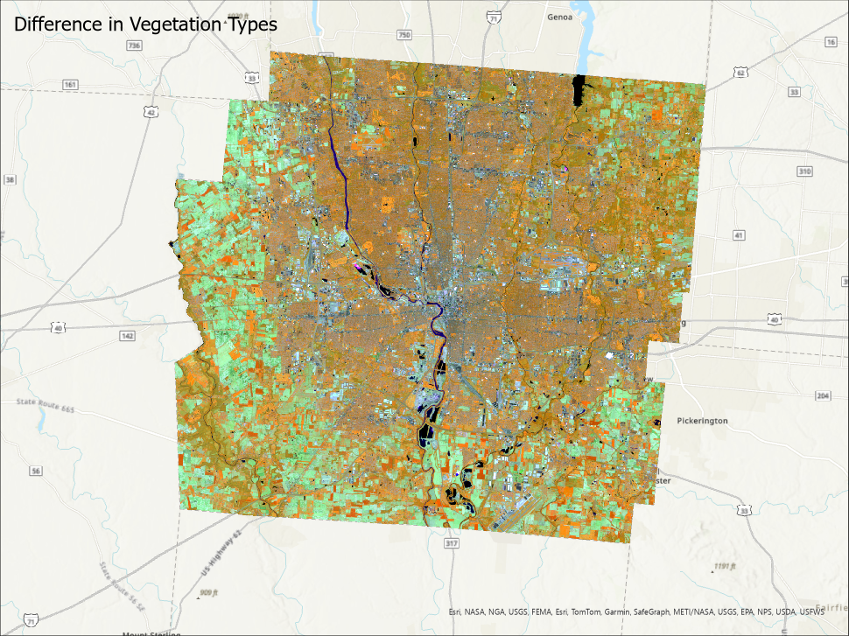

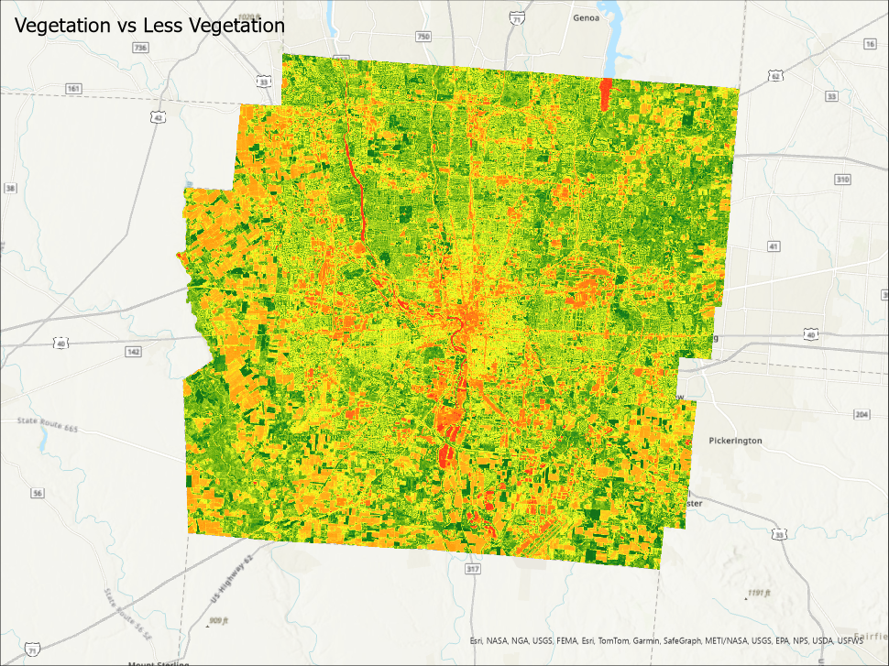

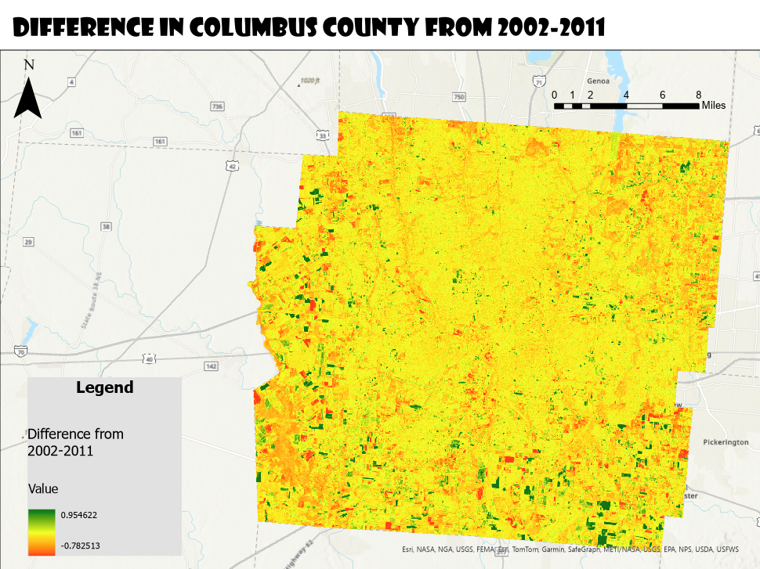

The NDVI map shows the changes in vegetation in Columbus County between 2002 and 2011. NDVI is a measure that tells us how much healthy vegetation is in an area, with higher values meaning more vegetation. In this map, green areas show where vegetation increased, while red areas show where it decreased over the years.

Most of Columbus County is yellow, which means there wasn’t much change in vegetation overall. However, we can see some patches of green, especially in rural parts of the county. This could be from new growth from reforestation or more active farming. On the other hand, there are some red spots indicating a loss of vegetation, which could be from urban development or changes in how the land is being used for agriculture.

